**Course Methods Year 12 test two 2022**

Student name: ________________ Teacher name: ________________

**Task type: Response**

**Time allowed for this task: _____40______ mins**

**Number of questions: ____7_______**

**Materials required: Upto 3 calculators/classpads allowed**

Standard items: Pens (blue/black preferred), pencils (including coloured), sharpener, correction fluid/tape, eraser, ruler, highlighters

Special items: Drawing instruments, templates, **one page of A4 notes doublesided**

**Marks available: ___40___ marks**

**Task weighting: _10___%**

**Formula sheet provided: Yes**

**Note: All part questions worth more than 2 marks require working to obtain full marks.**

Q1 (2 & 2 = 4 marks) (3.2.1)

Let ,

1. Determine an expression for the rate of change of .

|  |
| --- |
| **Solution** |
|  |
| **Specific behaviours** |
| P recognises that derivative is needed  P correct expression |

1. Determine  given that .

|  |
| --- |
| **Solution** |
|  |
| **Specific behaviours** |
| P anti differentiates and uses a constant c  P solves for constant |

Q2 (3 marks) (3.2.3-3.2.9)

Determine  in terms of  given that  and  when .

|  |
| --- |
| **Solution** |
|  |
| **Specific behaviours** |
| P anti- diffs and uses plus c  P sets up equation to solve for c  P solves for c (accept approx.) |

Q3 (4 marks) (3.2.21-3.2.22)

A particle travels along a straight line such that its acceleration at time  seconds is equal to . When  the displacement is 10 metres and when  the displacement is 20 metres. Determine the displacement when .

|  |
| --- |
| **Solution** |
|  |
| **Specific behaviours** |
| P anti diff to find v with constant stated  P anti diff to find x with a new constant  P solves for both constants  P displacement for t=3 |

Q4 (6 marks) (3.2.19-3.2.20)

Make a sketch showing the graphs of  and  indicating clearly on your sketch the coordinates (2 dp) of any stationary points, inflection (if any) and of any points where the functions intersect each other.

Determine the area between the graphs to 2 dp.

|  |
| --- |
| **Solution** |
| Area = 131.12 sq units (accept 131.13) |
| **Specific behaviours** |
| P states coordinates on sketch for both turning points  P states coordinates on sketch of inflection point  P shows line meeting cubic at 3 points  P states coordinates on sketch of all pts of intersection  P states integral(s) to calculate area between functions  Pstates area to 2 dp  (Note: max -1 if not 2 dp)  (Note: -2 if coordinates not given on sketch but stated elsewhere) |

Q5 (4 & 3 = 7 marks) (3.1.2-3.1.3)

Let 

1. Using **calculus** determine all stationary points and their nature.

|  |
| --- |
| **Solution** |
|  |
| **Specific behaviours** |
| P uses product rule to obtain first derivative  P equates derivative to zero and solves for two values  P uses first or second derivative test to determine nature with actual, values stated(accept approx)  P gives coordinates and nature of each stationary point(accept approx) |

1. Determine the values of any inflection points.

|  |
| --- |
| **Solution** |
| And x=0 |
| **Specific behaviours** |
| P shows second derivative equated to zero  P states at least two x values, accept approx  P states three x values, approx. |

Q6 (2, 2, 2 & 2 = 8 marks) (3.2.15-3.2.17)

Consider the function  which is graphed below.

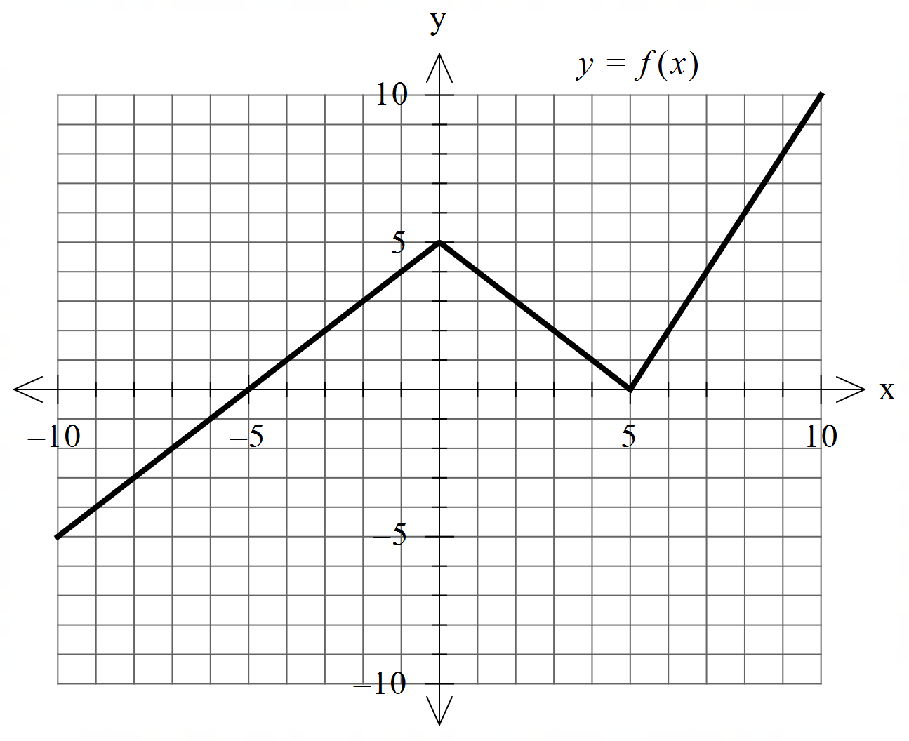

Determine the following.

1. .

|  |
| --- |
| **Solution** |
|  |
| **Specific behaviours** |
| P identifies negative result  P states total value |

1. .

|  |
| --- |
| **Solution** |
|  |
| **Specific behaviours** |
| P uses FTC  P states result |

1.  when .

|  |
| --- |
| **Solution** |
|  |
| **Specific behaviours** |
| P uses FTC  P states result |

1. The area enclosed between  and the line .

|  |
| --- |
| **Solution** |
|  |
| **Specific behaviours** |
| P uses two triangles  P states result  (If 4 triangles used giving 52.5 then 1 mark out of 2) |

Q7 (1, 3x= & 4 = 8 marks) (3.2.5-3.1.6)

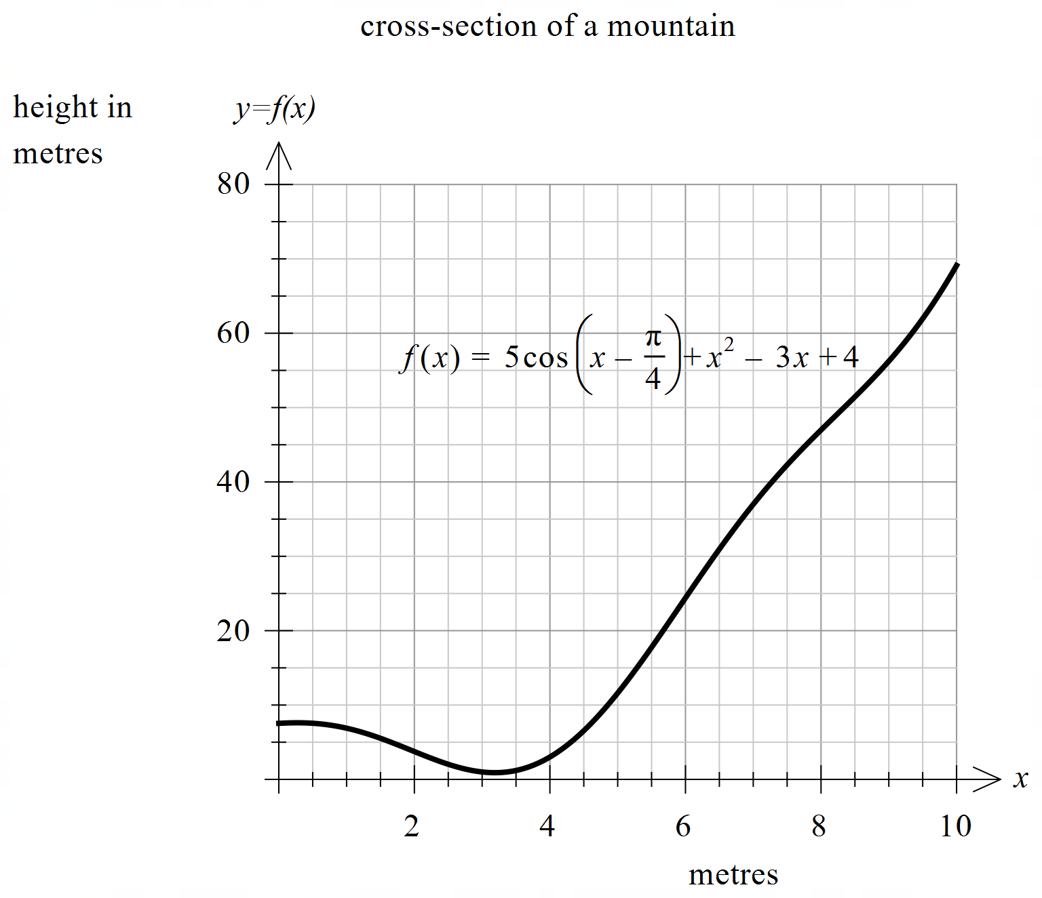The cross section of a mountain can be given by  for  metres where  = height at  metres.

1. Determine .

|  |
| --- |
| **Solution** |
|  |
| **Specific behaviours** |
| P states derivative |
|  |

1. Determine the minimum height of the mountain to 2 decimal places. Justify.

|  |
| --- |
| **Solution** |
| Graphical user interface, text, application  Description automatically generated  Graphical user interface, text, application  Description automatically generated  Graphical user interface, text, application, email  Description automatically generated |
| **Specific behaviours** |
| P differentiates and equates to zero.  P solves for two x values in domain  P uses first or second derivative test to select local min with y value stated to 2 dp  (no need for units) |

1. A water collection tank will be placed at the **steepest** part of the mountain. Determine the coordinates of this point to 2 decimal places. Justify.

|  |
| --- |
| **Solution** |
| Steepest point is at x=5.91 metres & y = 23.20 metres or 23.19(do not accept 23.2)  Note: **accept** the endpoint if derivative is given although the endpoints were not supposed to be examined. endpoint of x = 10 metres & y = 69.11 metres  Behaviours unchanged |
| **Specific behaviours** |
| P equates second derivative to zero.  P solves for 3 values of x  P states value of first derivative for at least 2 x values above.  P selects steepest point with x & y values rounded to 2 dp (2 possible answers)  Note : max -1 if 2 dp not used in entire question (no need for units) |

Continue with Q7

Extra working space